AGENCY

Protected Utility

AGENCY - SOP - Apple Corporate Device - User
 | 
Date 22 September 2020

Document Information

Document Acceptance for v1.0
Function | Date | Name | Position
Prepared: | 14-09-2020 | Collin McKeahnie | Consultant
Review | 21-09-2020 |  | Managing Consultant
Release | 22-09-2020 |  | Managing Consultant

Drafting and Release History
Version | Date | Author | Description
0.1 | 14-09-2020 | Collin McKeahnie | Initial Document
0.2 | 21-09-2020 |  | Review and update
1.0 | 22-09-2020 |  | Release

oobe contact details | oobe Pty Ltd
oobe contact details | | www.oobe.com.au  | GPO 111 Canberra City 2601  | ACN 123 977 846  | ABN 48 123 977 846

Contents
Setup Corporate iOS Device 4
Introduction 4
Purpose 4
Audience 4
Pre-Requisites 4
Enrolment 5

Setup Corporate iOS Device

Introduction
The AGENCY offer corporate iPhones as a fully managed mobile solution.

Purpose
This document is to guide a user through the initial setup of a corporate iOS device.

Audience
AGENCY end users

Pre-Requisites
- Apple device has been procured as a ‘corporate’ device through the AGENCY’s corporate Apple account
- The end user has an apple account
- The user has been added to the Azure Active Directory group ‘grp-iOS-Corporate-Users’

Enrolment
Step | Instruction | Screen Shot
 | Unbox and turn on device the device
 | Select your language | 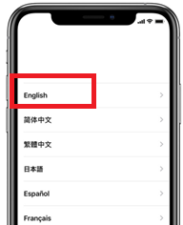
 | Select region as Australia | 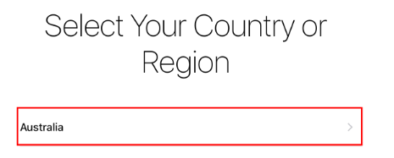
 | Select Set Up Manually from the Quick Start screen | 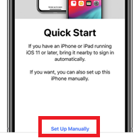
 | Join a Wi-Fi network.  If prompted choose to Trust the network | 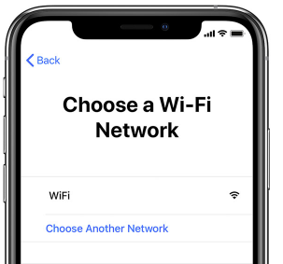
 | It may take a few minutes to activate your phone
 | The user will be presented with Remote Management screen informing them that Australian Bureau of Statistics will be managing this device  Select next from the top right | 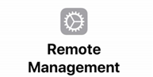
 | When asked to create a passcode select Passcode Options  Note: if the user does not enter an alphanumeric passcode at this point it is not a problem and the on boarding process will fix this later. | 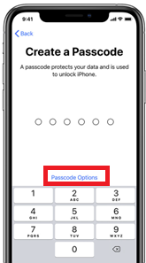
 | Select Custom Alphanumeric Code and then enter a passcode that meets the following conditions:  - 10 characters long  - 1 uppercase letter  - 1 lowercase  - 1 special character  - 1 number | 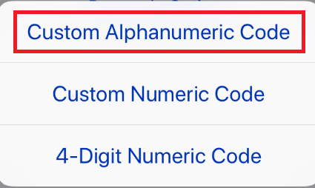
 | The user will be asked to sign in with their Apple ID. | 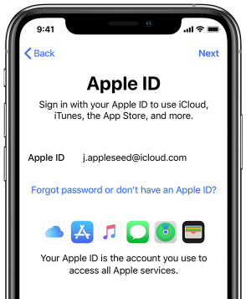
 | When presented with the Terms and Conditions screen select Agree | 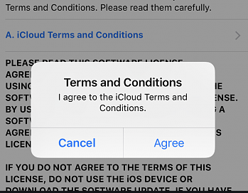
 | The user will be asked if they wish to enable Location Services select Enable Location Services | 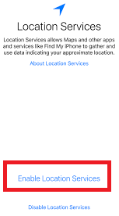
 | Select Don’t use iCloud Keychain | 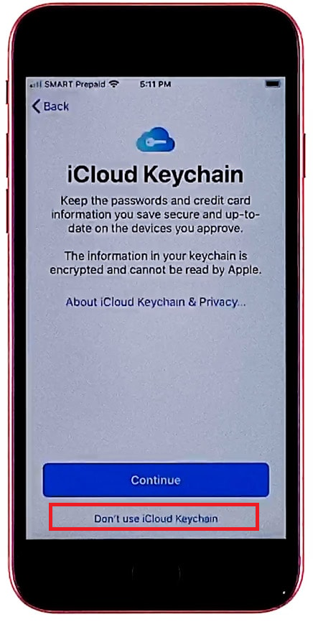
 | At this point the Out-of-box experience is complete. The user will need to wait for Comp Portal to become available, it should only take a few minutes. | 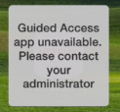
 | Open Comp Portal and log in with your AGENCY email address  The user will be prompted if their device is not compliant with the AGENCY device requirements. For example, their password may not be strong enough, in which case they can just return to the home screen and they will be prompted to enter a new password. | 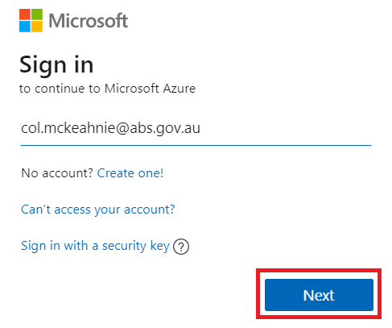
 | Enter your NGD password and select Sign In | 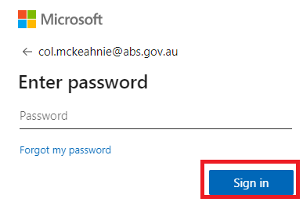
 | Select Begin | 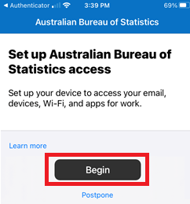
 | Select Done | 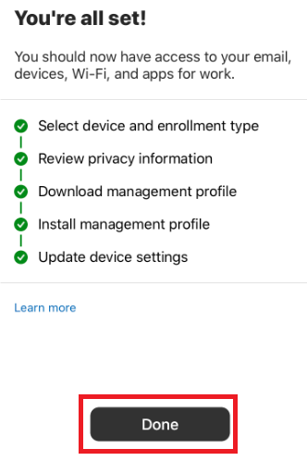
 | Select OK | 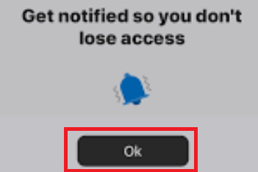
 | Select Allow | 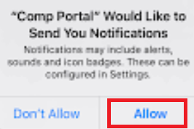
 | After a few minutes the Outlook and OneDrive apps will appear on the desktop.  Open the Outlook app | 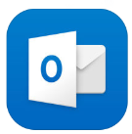
 | The user’s AGENCY email account will be automatically discovered by Outlook. Select Add Account | 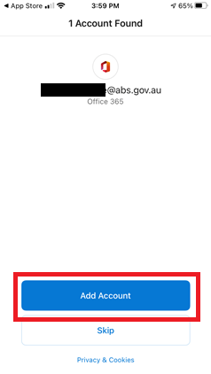
 | The user will now be able to access their corporate email account.

